Lab 2

Enter your data here:
Group DAY_XX | Name | Forename | Matr. No.
Member #1
Member #2
Member #3

Over time, your start-up company grows. They take another step and open another location. For this purpose, the network that you created in lab 1 will be successively expanded.

Task 1:
Create the network from the first internship next to it a second time, which should represent the second location. Select other networks and VLANs. Also test the reachability of the hosts and the VLANs. The second network should behave in the same way as the first network.
Please name the VLANs for the second location 21 and 22, analogous to 11 and 12 from the first lab! The new hosts should be called 4, 5 and 6. Also assign IP addresses for the hosts that match the respective VLANs, analogous to the addresses from location one.
At the end, each location receives a Cisco Router 3640, which can be found in the menu on the left under "Router" (the default router in GNS3). These two routers are additionally connected to each other. Do this by adding the router from the left menu under Routers and connecting the first location to the router (e.B. Ethernet0/1 <-> Ethernet0), as well as connecting the second location to another router. Also connect the two routers to each other.
Location 2
Location 1
(Network from P1)

Router R2
Router R1

Fig.: Sketch of the network to be created
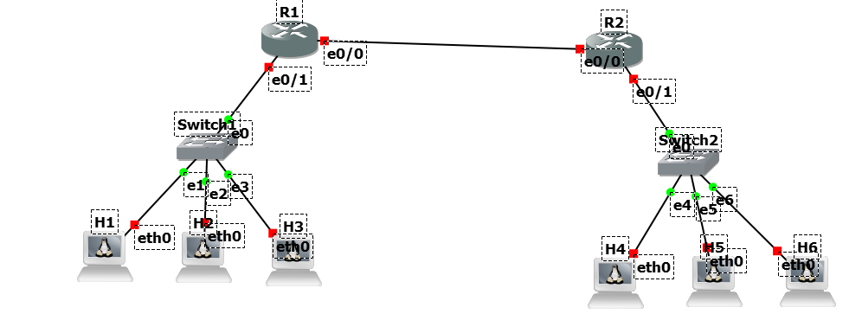
As a result, you should have the following network environment:

Now try to ping between two hosts from the respective sites.
Command:
Result:

Important: For further work with the Cisco router:
- To save the settings permanently, enter the command copy running-config startup-config after each change.
- Save your router configuration(s) after each task!

Task 2:

Now open the console on Router R1 to check its configuration and get to know the functionality better.
Which IOSv version is running on the router?
Command:

Result:

What is the operating status and what is the MAC address of the interface e0/0?
Command:
Result:

On which interfaces are the two locations connected to the router?
Command:

Also specify the respective port data for the networks in the table. You can add the IP address later if the router is further configured.
Switch port | Speed | Type | Duplex | IP address

Task 3:

Now add the corresponding VLANs each location has to the VLAN Database on the routers.
Commands:

Why is this step necessary? What is the result of this configuration?

Task 4:

Now add a subinterface or a virtual interface (depending on your chosen network interface between your routers and the switches) on the routers for each VLAN of the respective location. (e.B. VLAN 11 -> 192.168.11.254)
Commands:

Task 5:

Now configure the interfaces eth0 of the hosts, ascending from X.X.X.1 to match their VLANs. (e.g. VLAN 11 -> 192.168.11.1 for the first host in VLAN 11, 192.168.21.2 for the second host in VLAN 21 )
To do this, edit the file /etc/network/interfaces with the editor nano as in the previous lab 1. (IPv4 address, netmask, broadcast address, gateway)
Choose the correct ip address for the gateway
Enter the contents of the file interfaces from a random host.
Command:

What would be the command to be used in the command line?
Command:

Task 6:
Check the connectivity inside the network to the default gateway of this network
Is it possible to access the default gateway?

If not, where is the problem, and how can it be fixed?
Hint: Check the communication between Switch and Router
Command:

Task 7:
Check the connectivity inside the network between the networks.
Commands:

Is it possible to ping the interface of the assigned router?
Commands:

Task 8:
The connection between the routers connects the two locations and has the network 10.0.0.0/30. To do this, configure the corresponding interfaces.

Also check if the hosts can access these interfaces.
Command:

Result:

Task 9:
Now set up a static route between the locations on the routers.
Command:

Check again the accessibility of the hosts.
Command:
Result:

Appendix
Commands for the host network functions. Commands without parameters and options (see Linux man-pages):
Command | Description
ifconfig | Configuration and control of IP network interface
ping | Accessibility in the IP network
Arp | Display and modification of ARP cache
route | Viewing / Changing the IP Routing Table

Commands for the Cisco Router:
Command | Description
? | shows a list of possible commands/alternatives or parameters depending on the context.
exit | ends the session or goes one mode back
end | decreases one command level
no ... | negates (deletes) the following command line
show [Parameter] | displays information
show version | Displays information about the router
show running-config | displays the running configuration of the switch and router
show interfaces | displays all information about the interfaces
show interfaces status | displays a quick overview (status) of the interfaces
configure terminal | switches to configuration mode
interface ethernet x/x | select the interface to be configured in configuration mode
switchport mode trunk | Change the vlan mode of the port
encapsulation dot1q | Sets the port to trunk mode and encapsulation IEEE 802.1q
interface e0/1.1 | Create a subinterface for a given interface for example for intervlan-connection
interface vlan | Create a virtual interface for a vlan
vlan database | Managing VLANs of a router
vlan x | Definition of a VLAN X (x=VLAN No.)
ip address x.x.x.x y.y.y.y | Assigns the IP address "x.x.x.x" with the network mask "y.y.y.y" to the selected router interface.
ip routing | Activate routing on the device
ip route x.x.x.y mask IFACE | Configure a static route to the given net with the assigned subnet mask via the listed interface

